Introduction to AWS Certification Apr 1, 2026
This course item introduces the AWS Certified Solutions Architect Associate Certification exam prep course, outlining its purpose, structure, and key content areas.
Certification Overview
- The certification validates skills in designing secure, resilient, high-performing, and cost-optimized systems on AWS, intended for those with at least one year of experience in solutions architect roles.
- The exam tests abilities in designing multi-tier architectures, cost-effective solutions, and implementing AWS Well-Architected Framework principles including the new Sustainability pillar.
Exam Prep Course Structure
- The course is intermediate level and helps learners assess readiness by exploring exam domains, task statements, and mapping them to AWS development.
- It covers four main domains: designing secure architectures, resilient architectures, high-performing architectures, and cost-optimized architectures, with detailed focus on relevant AWS services and concepts in each.
Exam Preparation Tips and Format
- Learners are encouraged to evaluate their preparedness continuously and use practice questions to improve understanding and test-taking skills.
- The exam includes multiple choice and multiple response questions with complex scenarios requiring careful reading and elimination of distractors.
- Additional resources such as official exam guides, practice tests, and AWS training materials are recommended for thorough preparation.
Fundamentals Apr 1, 2026
This course item focuses on the essential fundamentals needed to prepare for the AWS Certified Solutions Architect - Associate exam and to understand AWS in practical scenarios.
Fundamentals of AWS and Cloud Computing
- Understand what AWS is and the core concepts of cloud computing, including the five criteria of cloud computing.
- Learn about AWS Global Infrastructure components such as Regions, Edge Locations, and Availability Zones, and their resilience levels (Availability Zone, Regional, Global).
Key AWS Concepts for Architecture Design
- Study the AWS Shared Responsibility Model to clarify security responsibilities between AWS and users.
- Explore the AWS Well-Architected Framework, which consolidates best practices for designing reliable, secure, efficient, and cost-effective cloud systems, including the new Sustainability pillar.
Additional Knowledge and Resources
- Gain general IT fundamentals like networking, virtualization, encryption, storage, security, DNS, and databases, which are crucial for both the exam and real-world roles.
- Utilize resources such as AWS Well-Architected online documentation, the Well-Architected Tool, and Labs to deepen understanding and practice applying concepts.
Domain 1 Introduction Apr 1, 2026
The course content introduces the first domain of the AWS Certified Solutions Architect Associate Exam Guide, focusing on designing secure architectures.
Design Secure Architectures Overview
- Emphasizes the importance of security in all stages, levels, and tiers of applications and architectures.
- Security is a constant theme throughout the exam, requiring understanding of security services and concepts.
Domain One Task Statements
- Design secure access to AWS resources.
- Design secure workloads and applications.
- Determine appropriate data security controls.
Course Approach
- The domain is broken down into task statements addressed individually in upcoming videos.
- The course aims to prepare learners for the exam by evaluating their readiness in these security-related areas.
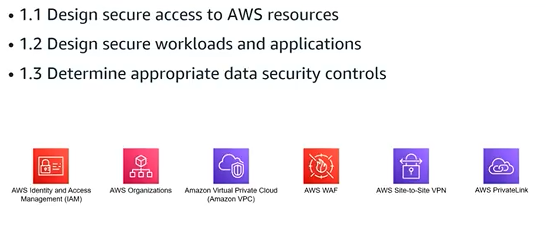
Design secure access to AWS resources Apr 1, 2026
This lecture focuses on designing secure access to AWS resources, a critical aspect of AWS architecture.
AWS Account Fundamentals
- Understanding AWS accounts is essential for secure access; the root user has full permissions that cannot be modified, posing a security risk.
- Best practices include securing the root user with multi-factor authentication and creating IAM users with limited permissions following the principle of least privilege.
AWS Identity and Access Management (IAM)
- IAM is a global service that manages access across all AWS regions, involving users, groups, and roles with no default permissions.
- Learn how to create and manage IAM identities, assign roles, and use federated identities from external directories for secure access.
Policies and Permissions
- Policies define permissions and come in two types: identity-based (attached to users, groups, roles) and resource-based (attached to resources like S3 buckets).
- Understand policy structure, decision logic, and how to interpret policies to control access granularity effectively.
Security and Traceability Tools
- Use AWS services like Security Token Service, Control Tower, Organizations, and service control policies to enforce security standards.
- Implement traceability through monitoring, alerting, and auditing to maintain visibility and automate responses to access events.
Application Access and Best Practices
- Avoid hard coding credentials in applications; instead, use secure methods for API access.
- Follow best practices for handling credentials and controlling application access to AWS APIs.
Overall, mastering these concepts is vital for designing secure AWS architectures and preparing for the AWS Certified Solutions Architect - Associate exam.
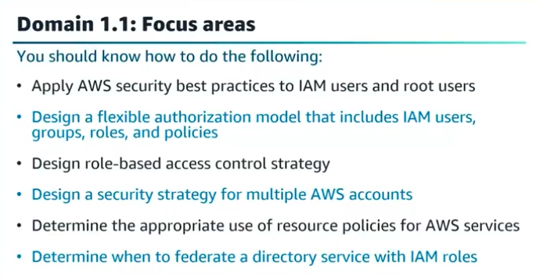
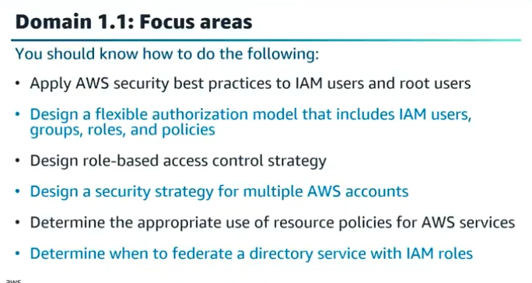
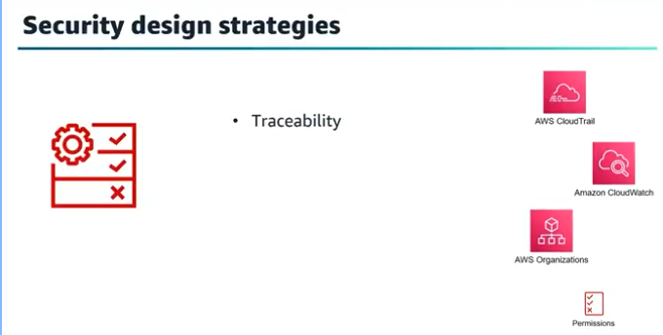

Walkthrough question 1.1 Apr 1, 2026
This course item focuses on preparing learners for the AWS Certified Solutions Architect - Associate exam by using walkthrough questions to build exam readiness.
Purpose of Walkthrough Questions
- Provide exposure to question types similar in quality and difficulty to the actual exam.
- Teach methods to analyze multiple-choice questions, identify key words, and eliminate distractors.
- Help learners identify knowledge gaps and reinforce strengths through practice.
Example Question Breakdown
- The sample question asks about securing the AWS root user login with best practices.
- Key words identified include "root user," "best practices," and "secure login."
- Correct answers are enforcing MFA (Multi-Factor Authentication) and using complex passwords for root user logins.
- Distractors explained: Access keys should not be used for root user logins, root user cannot assume roles, and deleting the root account is not feasible.
Exam Strategy Tips
- Carefully read the question stem and all answer choices.
- Identify key words to focus on what the question is asking.
- Eliminate clearly incorrect answers (distractors).
- Reassess remaining options to select the best answers, especially when multiple answers are required.
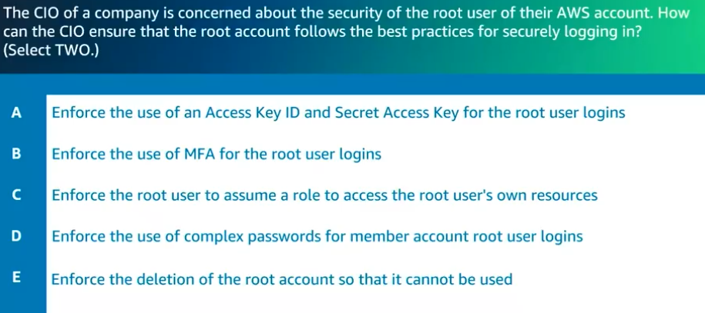

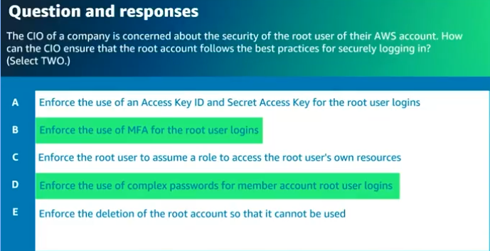

Design secure workloads and applications Apr 1, 2026
This course lecture focuses on designing secure workloads and applications in AWS, emphasizing secure access to AWS services and resources.
Amazon VPC and Networking Fundamentals
- Understand the difference between default and custom Amazon VPCs, their security configurations, and that VPCs are regional services.
- Know networking basics such as protocols, CIDR, subnetting, routing, security filters, gateways, and the role of subnets as Availability Zone resilient components.
Securing Network Architecture and Access
- Learn to design secure multi-tier application architectures using security groups, network ACLs, route tables, and NAT gateways for granular traffic control.
- Understand routing within VPCs, including handling traffic from on-premises via VPN, and the use of AWS service endpoints like PrivateLink, VPC peering, transit gateways, and Direct Connect.
AWS Security Services and Best Practices
- Familiarize with services for protecting sensitive data and identities, such as Amazon Macie for PII, Amazon Cognito for user identity management, and Amazon GuardDuty for threat detection.
- Know how to use firewalls and proxy services like AWS Shield, AWS WAF, IAM Identity Center, Secrets Manager, and Systems Manager Parameter Store, including their use cases and differences for securing applications and managing secrets.
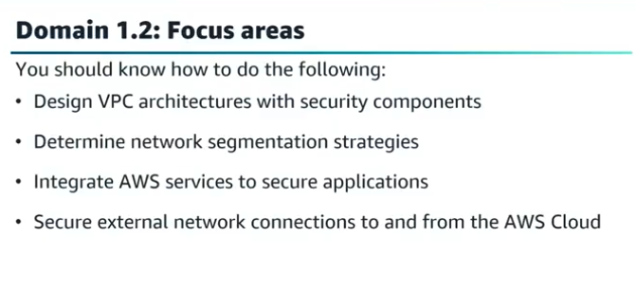
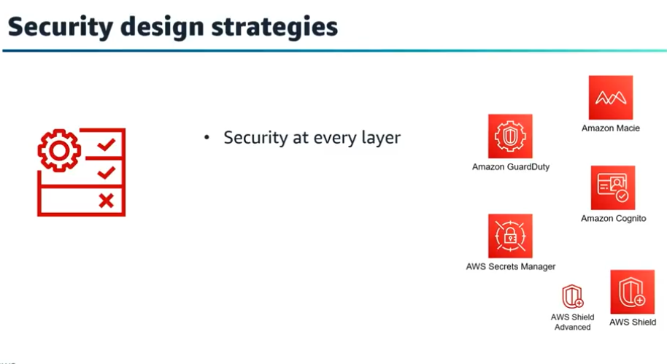
Walkthrough question 1.2 Apr 1, 2026
This course item focuses on understanding how to secure network traffic for applications running on Amazon EC2 instances within the same subnet by choosing the appropriate AWS security controls.
Key Concepts of Network Traffic Security
- The question involves securing inbound traffic for two applications on separate EC2 instances in the same subnet, with different requirements for HTTP and HTTPS traffic.
- Key phrases include "same subnet," "allow and block inbound traffic," and specific protocols (HTTP for Application A, HTTPS for Application B).
Security Controls Options and Their Suitability
- Security groups are the correct choice because they act as virtual firewalls at the instance level, allowing specific inbound traffic and blocking all else.
- Network Access Control Lists (NACLs) operate at the subnet level and apply the same rules to all instances in the subnet, so they cannot differentiate between the two applications' requirements.
Why Other Options Are Incorrect
- VPC peering enables communication between different VPCs but does not provide traffic-blocking capabilities.
- Route tables direct network traffic but do not control or block inbound traffic to instances.
Exam Strategy Tips
- Carefully read the question and answers to identify key requirements.
- Eliminate distractors by understanding the scope and function of each AWS networking component.
- Choose the best answer based on how well it meets the specific security needs described.
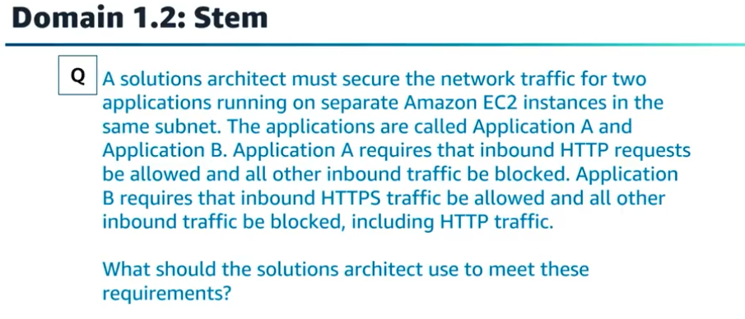
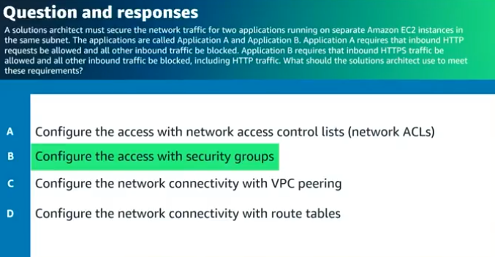

Determine appropriate data security controls Apr 1, 2026
This course item focuses on determining appropriate data security controls within AWS environments, emphasizing the protection of data at every layer.
Data Encryption Fundamentals
- Understand encryption at rest and in transit, including their purposes and differences.
- Learn key concepts such as plaintext, ciphertext, algorithms, and the types of encryption keys (symmetric and asymmetric).
AWS Encryption and Key Management Services
- Explore AWS services like AWS KMS, AWS CloudHSM, and AWS Certificate Manager for managing encryption keys and securing data.
- Understand Amazon S3 encryption options: client-side encryption and server-side encryption with various key management choices.
Data Security Best Practices and Compliance
- Learn about data classification, defense in depth, and compliance tools like AWS Artifact.
- Understand disaster recovery strategies, backup options, and how AWS services support data protection and recovery.
This knowledge is essential for designing secure AWS architectures and preparing for the AWS Certified Solutions Architect - Associate exam.
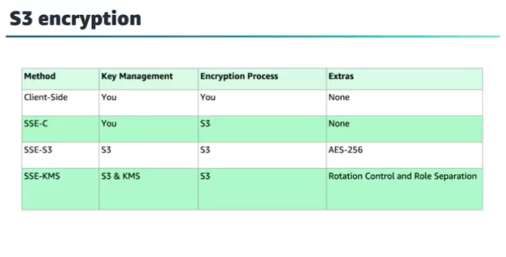
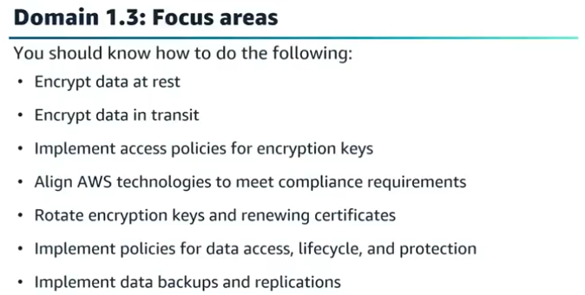
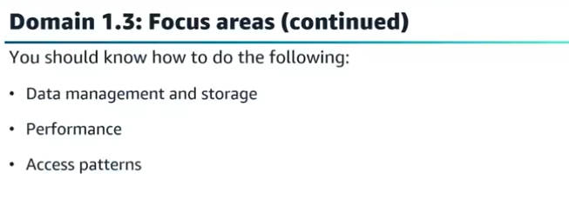
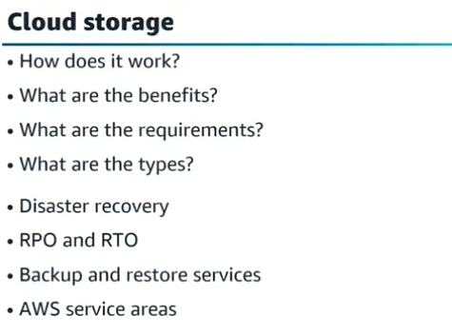
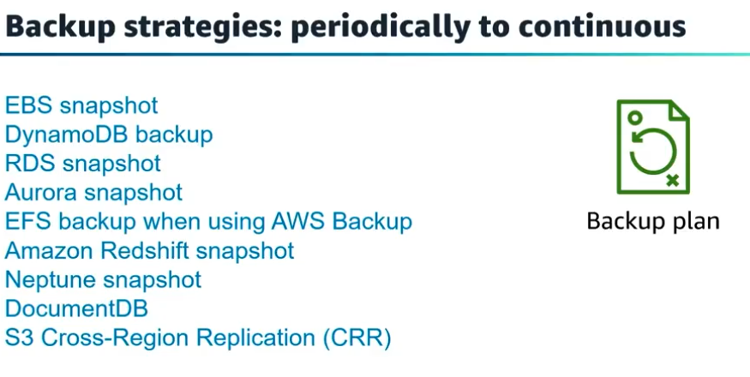
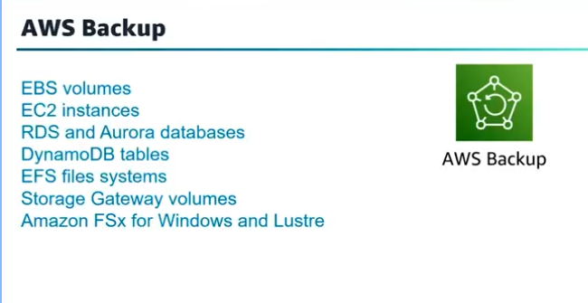

Walkthrough question 1.3 Apr 1, 2026
This course item focuses on a walkthrough question related to implementing a secure data encryption solution that meets regulatory requirements, emphasizing key generation, storage, and access control.
Key Concepts in the Question
- The question requires identifying key words such as "regulatory requirements," "security," "durability," and "cryptographic data keys."
- It asks for the most secure solution to generate, store, and control cryptographic keys.
Answer Options and Analysis
- Option A: Use AWS KMS to generate keys and control access with KMS key policies; this is the correct answer as it ensures security and durability.
- Option B: Use AWS KMS and import keys to AWS Certificate Manager; incorrect because Certificate Manager is for SSL keys, not data keys.
- Option C: Use a third-party solution with encrypted instance store volumes; incorrect due to instance store volumes being ephemeral and not durable.
- Option D: Use OpenSSL for key generation and store keys in S3 with KMS policies; incorrect because S3 does not support direct key management and KMS policies apply only to keys in KMS.
Exam Strategy Tips
- Identify key words in the question carefully.
- Eliminate distractors by understanding the purpose and limitations of AWS services.
- Choose the answer that fully meets all requirements for security and durability.
This approach helps prepare for the AWS Certified Solutions Architect - Associate exam by practicing question analysis and understanding AWS key management services.
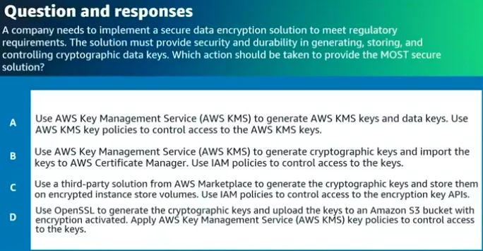

Domain 1 – wrap up Apr 1, 2026
This lecture focuses on key security concepts and best practices for preparing for the AWS Certified Solutions Architect - Associate exam, particularly in Domain 2.
Security Best Practices and Permissions Management
- Emphasizes the principle of least privilege, granting only necessary permissions.
- Discusses services for managing permissions in multi-account environments, such as AWS Control Tower, AWS Service Catalog, and AWS Organizations.
Identity and Access Management (IAM)
- Highlights understanding when to use IAM roles versus IAM users.
- Explains different types of policies: identity policies, resource policies, permissions policies, and service control policies, including how overlapping allow and deny rules are evaluated.
AWS Security and Monitoring Services
- Covers federated access methods, AWS Single Sign-On, and AWS Directory Service use cases.
- Reviews monitoring tools like Amazon CloudTrail, Amazon CloudWatch, and VPC Flow Logs.
- Introduces security services including AWS Shield, AWS WAF, AWS Secrets Manager, and AWS Systems Manager Parameter Store.
- Discusses data protection in transit and at rest, and when to use AWS KMS versus AWS CloudHSM.
The lecture encourages a solid understanding of these services and concepts to effectively choose the right AWS security tools and configurations for different scenarios, which is crucial for passing the certification exam.
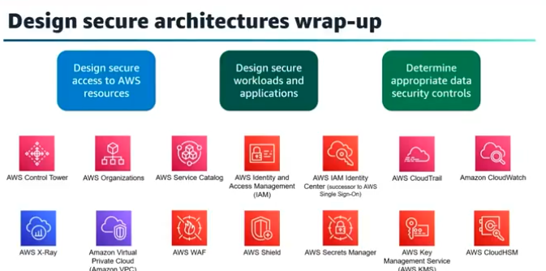

When choosing between AWS Key Management Service (KMS) and AWS CloudHSM, the decision typically hinges on your specific compliance requirements, the level of control you need over the hardware, and your budget.

AWS Key Management Service (KMS)
AWS KMS is a fully managed service that makes it easy to create and control the cryptographic keys used to protect your data. It is integrated with most other AWS services.
- Managed Service: AWS handles the availability, scalability, and physical security of the Hardware Security Modules (HSMs).
- Multi-tenant Hardware: Your keys are stored on HSMs shared with other AWS customers, though they are logically isolated.
- Compliance: Validated to FIPS 140-2 Level 2 overall (with some components at Level 3).
- Integration: Natively integrated with over 100 AWS services (S3, EBS, RDS, etc.).
- Cost: Low cost; you pay per key per month and per API request.

AWS CloudHSM
AWS CloudHSM provides managed hardware security modules in the AWS Cloud. It is a "cloud-native" version of a traditional on-premises HSM.
- Dedicated Hardware: You get exclusive access to a physical HSM instance within your VPC. AWS manages the hardware but has no access to your keys.
- Single-tenant: The hardware is dedicated solely to your account.
- Compliance: Validated to FIPS 140-2 Level 3, which is often a requirement for highly regulated industries (finance, government, healthcare).
- Industry Standards: Supports standard APIs like PKCS#11, Java Cryptography Extensions (JCE), and Microsoft CryptoNG (CNG).
- Cost: Higher cost; you pay an hourly fee for each HSM instance you provision.

Key Comparison Table
Feature | AWS KMS | AWS CloudHSM
Tenancy | Multi-tenant (shared hardware) | Single-tenant (dedicated hardware)
FIPS 140-2 Level | Level 2 (Level 3 for some parts) | Level 3
Management | Fully managed by AWS | Hardware managed by AWS; Keys/Users managed by you
Ease of Use | High (Integrated with AWS ecosystem) | Moderate (Requires manual setup in VPC)
Scaling | Automatic and seamless | Manual (Add/remove HSMs from a cluster)
Connectivity | AWS API / SDK | PKCS#11, JCE, CNG
Cost Model | Pay-per-use ($1/key/mo + usage) | Hourly ($1.45+ per hour per HSM)
[Image comparing AWS KMS and AWS CloudHSM security levels and management]

Which one should you choose?
Choose AWS KMS if:
- You want a "set it and forget it" solution.
- You need to encrypt data in other AWS services (like S3 buckets or EBS volumes).
- Your compliance requirement is FIPS 140-2 Level 2.
- You want to minimize costs.
Choose AWS CloudHSM if:
- You require FIPS 140-2 Level 3 compliance.
- You need to use standard cryptographic APIs (PKCS#11) for legacy applications.
- You must have absolute, sole control over the hardware and the users who can access it.
- You are performing high-volume cryptographic operations where a dedicated instance is more performant.
Domain 2 Introduction Apr 1, 2026
This course item introduces Domain 2 of the AWS Certified Solutions Architect - Associate exam preparation, focusing on designing resilient architectures.
Designing Resilient Architectures
- A resilient workload can recover from stress caused by loads, attacks (accidental or deliberate), and component failures.
- The domain emphasizes high availability, fault tolerance, disaster recovery, elasticity, and scalability.
Task Statements in Domain 2
- The domain is divided into two main tasks: designing scalable and loosely coupled architectures, and designing highly available and/or fault-tolerant architectures.
- Solutions should be based on thorough examination of architecture requirements and understanding that these topics are interconnected.
Course Structure and Exam Preparation
- The course will address each task statement individually with detailed knowledge and skills.
- Learners are encouraged to refer to the exam guide and prepare for the exam readiness evaluation in subsequent videos.
Design scalable and loosely coupled architectures Apr 1, 2026
This lecture focuses on designing scalable, loosely coupled, and resilient architectures in AWS to ensure applications perform well under varying loads and continue running despite failures.
Scaling and Elasticity
- Scaling involves increasing or decreasing system capacity based on demand, with vertical scaling adding resources to a single instance and horizontal scaling adding more instances.
- Elasticity uses automation and horizontal scaling to dynamically match capacity with fluctuating demand, optimizing performance, cost, and operational excellence.
Compute and Database Options
- Different compute options include containers, serverless (e.g., AWS Lambda), and virtual instances (EC2), each suited for different workloads and performance needs.
- AWS offers various database services like DynamoDB (NoSQL), RDS (managed relational), Aurora (cloud-native relational), and Redshift (data warehousing), with strategies like Read Replicas and Multi-AZ for scalability and availability.
Decoupling and Serverless Architectures
- Loosely coupled architectures keep components autonomous, improving resilience and scalability, using synchronous or asynchronous integration patterns.
- AWS services such as API Gateway, SQS, Lambda, and Transfer Family support building scalable, decoupled, and serverless applications that handle high throughput and improve fault tolerance.
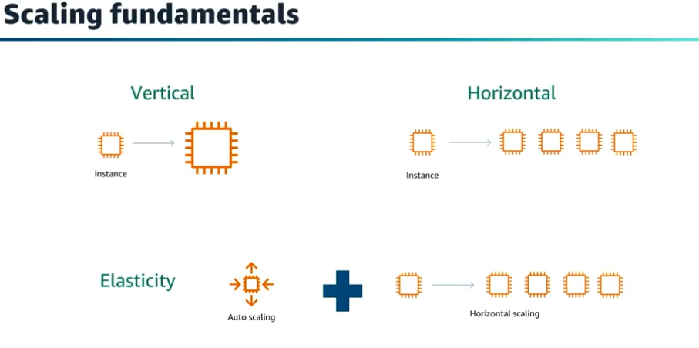
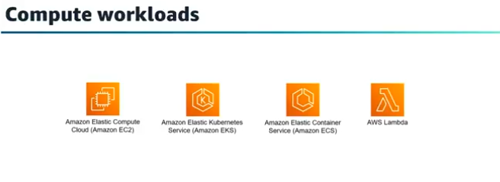
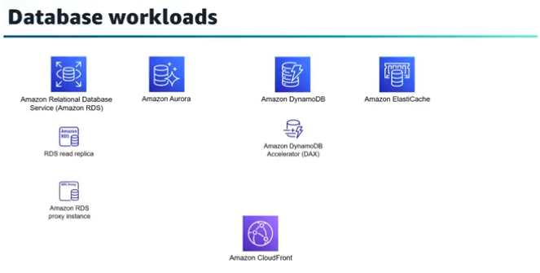
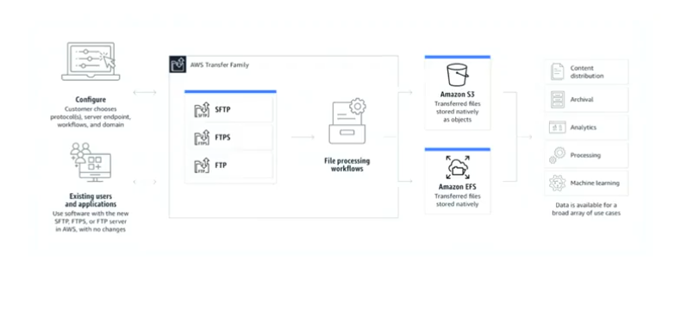
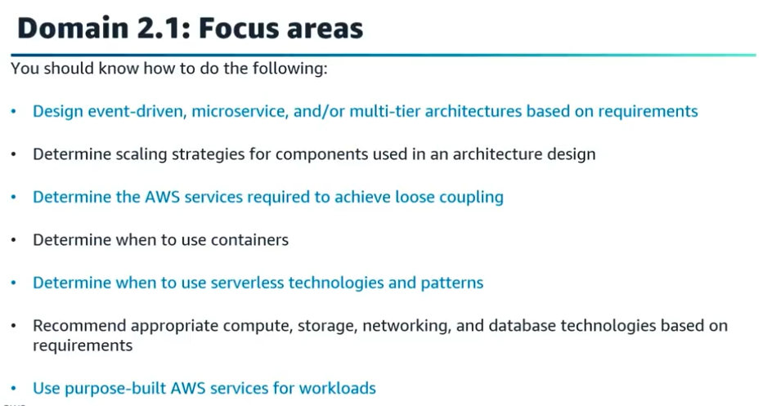

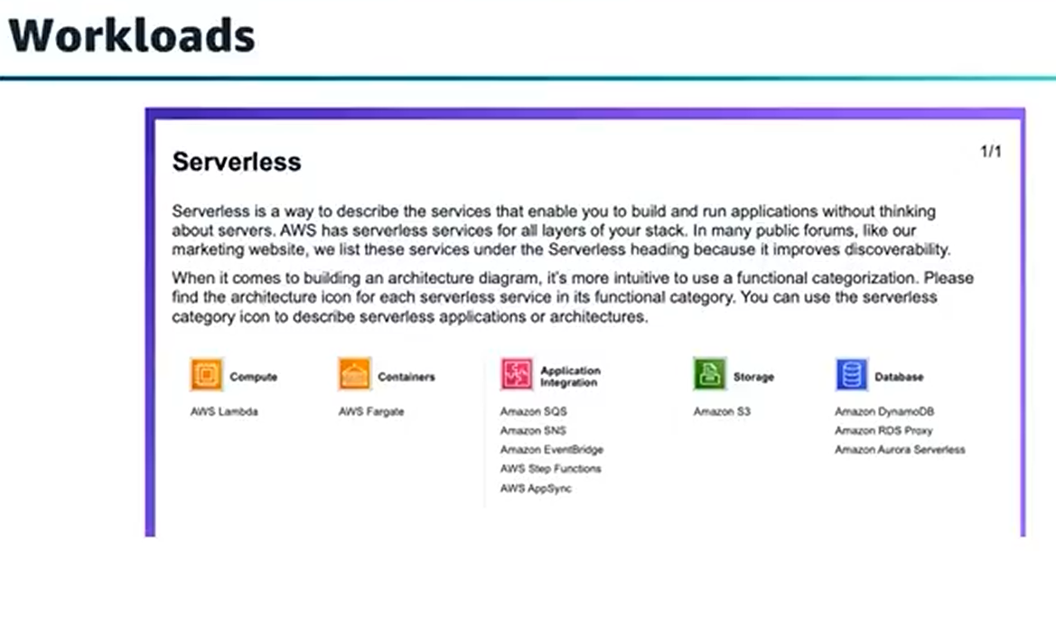
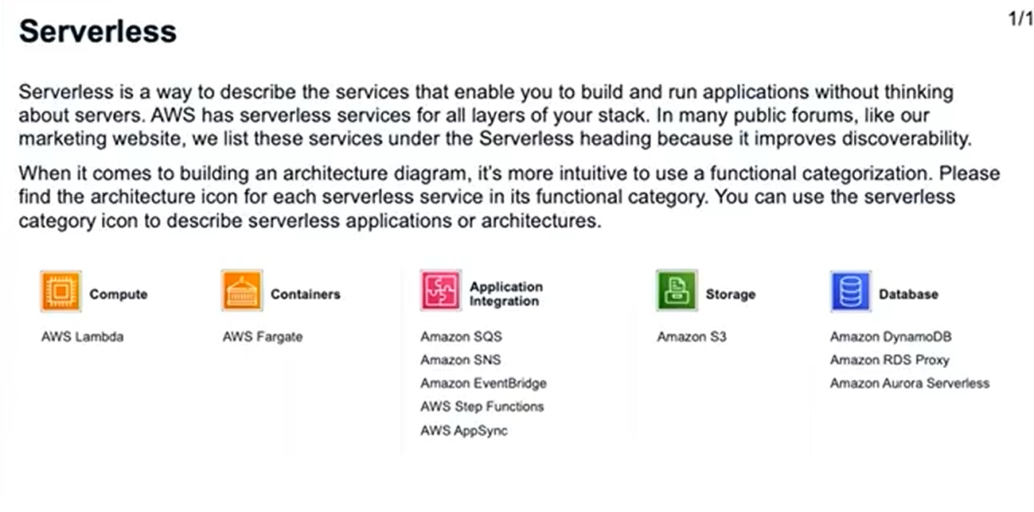
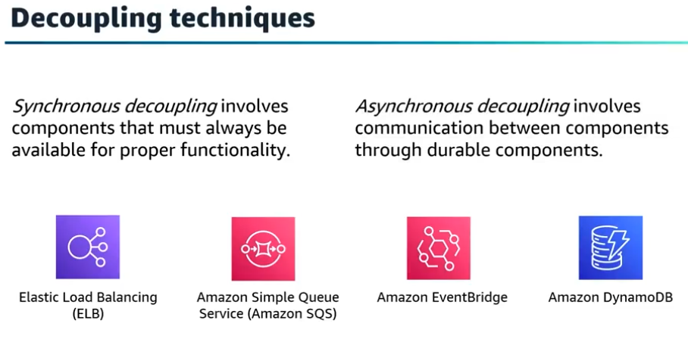

Walkthrough question 2.1 Apr 2, 2026
This course item focuses on how to design an architecture that ensures data records are processed exactly once, avoiding duplicates in a high-volume sensor data scenario.
Understanding the Problem
- The system receives a high volume of sensor data that is queued before processing.
- The current architecture processes some data records more than once, causing duplicates.
Evaluating Solution Options
- Amazon Kinesis Data Streams and Firehose can cause duplicate records due to producer and consumer retries.
- Amazon Simple Notification Service (SNS) is a messaging service, not a queuing service, and is unsuitable for handling high-volume queued data.
Recommended Solution: Amazon SQS FIFO Queue
- Using Amazon Simple Queue Service (SQS) FIFO queue ensures first-in-first-out delivery and exactly-once processing.
- The FIFO queue preserves message order and prevents duplicates by delivering messages once and retaining them until processed and deleted.
Exam Strategy Tips
- Identify keywords in the question such as "high volume," "queue," and "duplicate processing."
- Eliminate incorrect options by understanding service characteristics.
- Choose the best answer based on features that meet the requirement of exactly-once processing and ordered delivery.
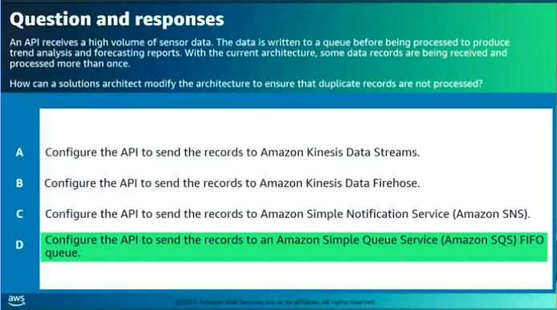

Design highly available and/or fault-tolerant architectures Apr 2, 2026
This lecture focuses on designing highly available, fault tolerant, and disaster recovery architectures in AWS, which are key concepts for the AWS Certified Solutions Architect - Associate exam.
High Availability and Fault Tolerance
- High availability aims to keep systems operational as much as possible by quickly recovering from failures, though some downtime may occur.
- Fault tolerance means the system continues operating without downtime even if one or more components fail, typically requiring more resources and cost.
Disaster Recovery Planning
- Disaster recovery involves pre-planning and having strategies to recover systems quickly after a disaster, including offsite backups and regular recovery exercises.
- Recovery Time Objective (RTO) and Recovery Point Objective (RPO) are critical metrics to determine acceptable downtime and data loss.
AWS Services and Strategies for Resilience
- Use AWS services like Amazon S3, EFS, RDS Multi-AZ, Aurora Global Database, DynamoDB Global Tables, and RDS Proxy to enhance availability and disaster recovery.
- Architectures should address single points of failure using load balancers, auto scaling, multi-AZ deployments, and global failover with Route 53 and Global Accelerator.
- Monitoring and automation tools like CloudWatch, X-Ray, and EventBridge help maintain and improve system resilience continuously.
This content prepares you to design robust AWS architectures that meet business continuity requirements and pass the certification exam.
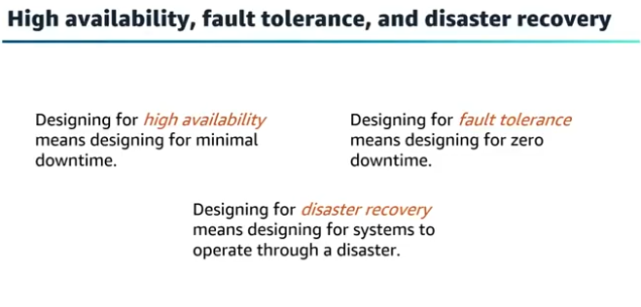
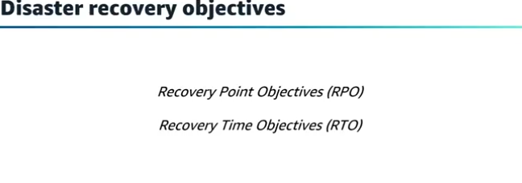
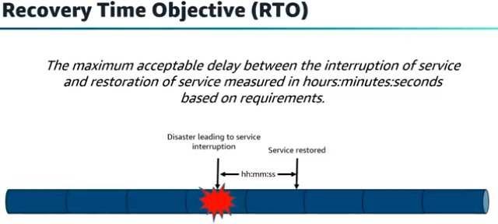
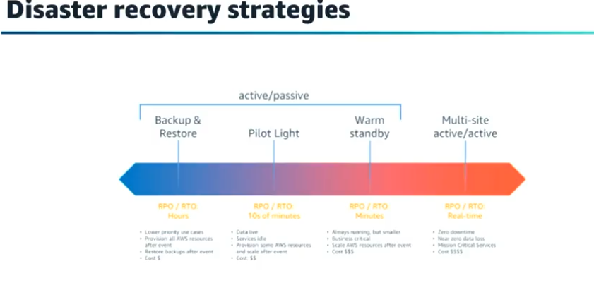
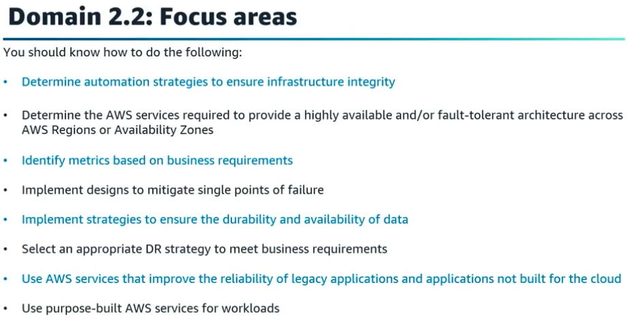
Walkthrough question 2.2 Apr 2, 2026
This course item focuses on designing a resilient and highly available cloud architecture to handle increased demand for a gaming company experiencing exponential growth.
Key Concepts of High Availability and Scalability
- The question emphasizes the need for a solution that ensures customers can access resources reliably despite growth.
- High availability requires deploying resources across multiple Availability Zones to avoid single points of failure.
Evaluation of Solution Options
- Option A is incorrect because it uses only one Availability Zone, which does not provide high availability.
- Option B is incorrect because peered VPCs alone do not guarantee application high availability.
Recommended Solution and Best Practices
- Option C is correct: a Network Load Balancer with an Auto Scaling group spanning two Availability Zones provides resilience and can handle volatile traffic with low latency.
- Option D is incorrect because Application Load Balancers cannot target instances across multiple AWS Regions.
- The approach includes reading questions carefully, identifying keywords, eliminating distractors, and selecting the best answer based on AWS architectural principles.
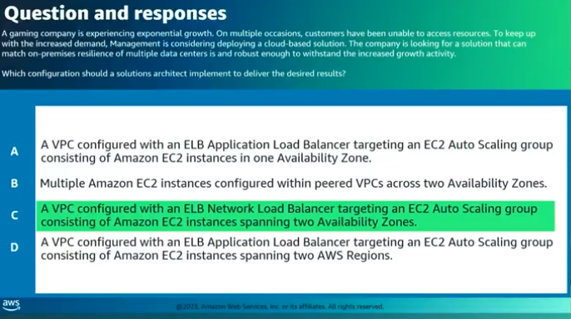

Domain 2 – Wrap up Apr 2, 2026
This lecture focuses on designing resilient, scalable, and cost-optimized architectures using AWS services.
Key Concepts of AWS Scalability and Cost Optimization
- AWS allows automatic scaling of resources up or down to match application demand, reducing costs by paying only for what is used.
- Understanding horizontal vs. vertical scaling and using services like Amazon EC2 Auto Scaling and AWS Auto Scaling is essential.
High Availability, Fault Tolerance, and Disaster Recovery
- Know the difference between highly available and fault-tolerant workloads and how to design for resilience across availability zones and regions.
- Use Elastic Load Balancing, Amazon EC2 Auto Scaling, Amazon Route 53, and AWS Global Accelerator to create self-healing environments.
- Understand disaster recovery strategies such as Backup and Restore, Pilot Light, and Warm Standby.
Serverless and Loosely Coupled Architectures
- Many AWS-managed services like SQS, Lambda, and Fargate have built-in resilience and support loosely coupled architectures.
- Know the difference between stateful and stateless applications and how to scale stateful applications horizontally using services like Amazon EFS and Amazon FSx.
- Use sticky sessions with Application Load Balancer to maintain user sessions on the same instance and decouple architectures with services like SQS and Elastic Load Balancing.
- Offload frequent traffic to data stores such as ElastiCache, DynamoDB Accelerator, and Read Replicas for improved performance.
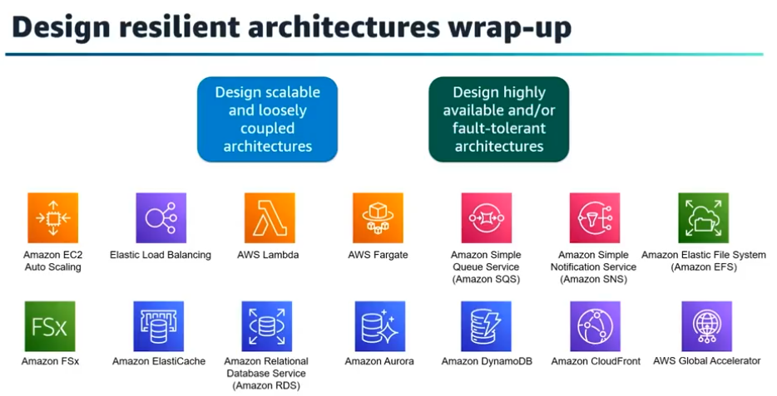

Domain 3 Introduction Apr 2, 2026
This course item introduces Domain 3 of the AWS Certified Solutions Architect - Associate exam preparation, focusing on designing high-performing architectures.
Key Layers in High-Performing Architectures
- Important layers include compute, storage, database, networking, and data ingestion/transformation.
- Security and authentication are also considerations but are not the main focus here.
Approach to Designing Solutions
- Optimal solutions vary by workload and often combine multiple AWS services and features.
- A data-driven approach using benchmarking and load testing is essential for performance optimization.
Domain 3 Task Statements
- Determine high-performing and/or scalable storage solutions.
- Design high-performing and elastic compute solutions.
- Determine high-performing database solutions.
- Determine high-performing and/or scalable network architectures.
- Determine high-performing data ingestion and transformation solutions.
Next Steps
- The course will address each task statement individually in upcoming videos.
- The first focus will be on high-performing and/or scalable storage solutions, followed by exam readiness evaluation.
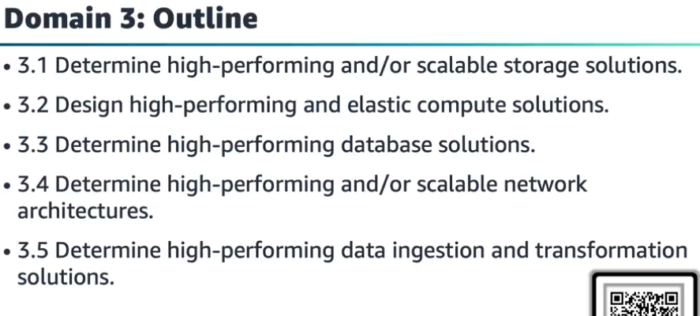

Determine high-performing and/or scalable storage solutions Apr 2, 2026
This course item focuses on determining high-performing and scalable storage solutions in AWS, essential for the AWS Certified Solutions Architect - Associate exam.
AWS Storage Types and Scaling
- AWS offers three storage types: object (S3), block (EBS), and file (EFS), each suited for different access patterns and performance needs.
- Scaling varies by service: EBS requires manual volume modification for scaling, while EFS scales automatically as files are added or removed.
Key Storage Services and Features
- S3 is ideal for big data, backup, and recovery, with features like multiple storage classes, multi-part uploads, and global resiliency.
- EBS provides persistent block storage with various volume types and supports snapshots stored in S3 for backup and disaster recovery.
- EFS offers shared file storage, suitable for development environments and large repositories, with performance modes and lifecycle policies.
Performance and Use Case Considerations
- Low-latency needs favor EBS volumes with configurable performance.
- Integration with services like S3 Accelerator and CloudFront can enhance upload and retrieval speeds.
- Understanding future storage growth and capacity limits is crucial for selecting the right storage solution.
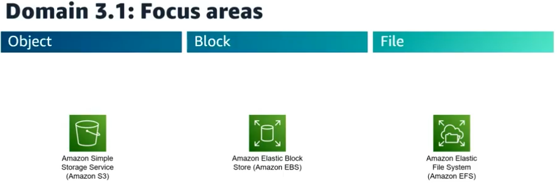
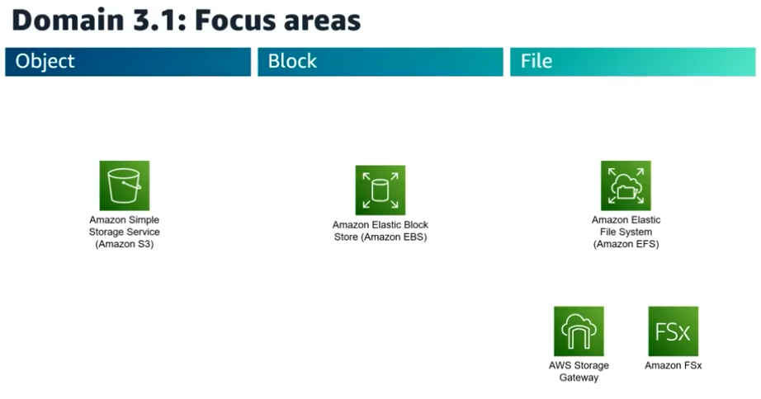
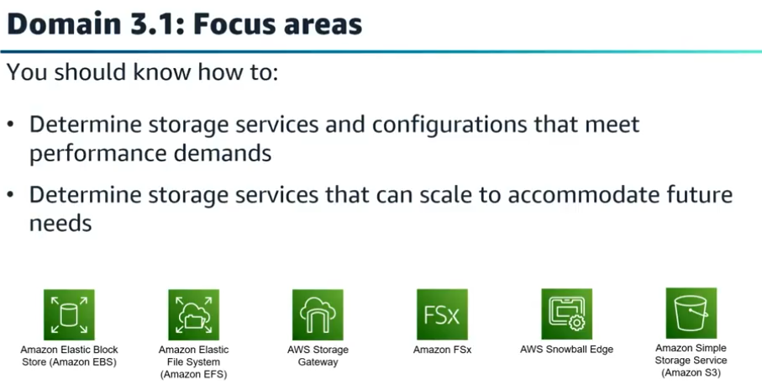

Walkthrough question 3.1 Apr 2, 2026
This course item focuses on how to efficiently upload large video files to an Amazon S3 bucket with the ability to easily resume failed uploads.
Key points about the upload scenario:
- Files range from 100 to 500 megabytes, which is significant for choosing the upload method.
- The main requirement is to resume failed upload attempts easily.
- The goal is to complete uploads in the least amount of time.
Recommended solution and reasoning:
- Use the AWS CLI with the S3 copy command, which automatically performs multipart uploads for large files.
- Multipart upload is ideal for files over 100 megabytes, improving throughput and enabling quick recovery from network failures.
- The AWS CLI command simplifies the process by handling multipart uploads internally, saving time and effort.
Why other options are less suitable:
- Manually splitting files into 5 MB parts and uploading them is unnecessary and inefficient for files of this size.
- Uploading via the AWS Management Console does not support automatic multipart uploads or resume capabilities.
- Using SFTP with AWS Transfer Family adds complexity and does not facilitate easy resumption of uploads.
Overall, the best practice for uploading large files to S3 with resume capability and speed is to use the AWS CLI copy command, leveraging multipart upload automatically.
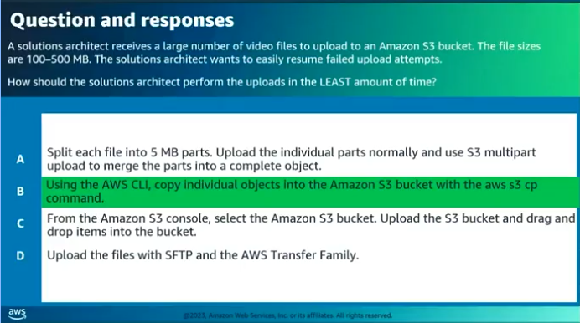

Design high-performing and elastic compute solutions Apr 2, 2026
This lecture focuses on designing high-performing and elastic compute solutions in AWS, emphasizing the importance of scalability and appropriate service selection.
AWS Compute Options
- Compute resources in AWS come in three forms: instances (Amazon EC2), containers (Amazon ECS and EKS), and functions (AWS Lambda).
- Each compute option has specific characteristics, such as EC2 instance types with varying CPU, memory, and network capabilities; ECS supports container orchestration with EC2 or serverless Fargate; Lambda runs code in response to events with a 15-minute execution limit.
Architecting for Scalability and Performance
- Scalability depends on design choices, including selecting the right compute resources and integrating services like Elastic Load Balancing and Amazon SQS to decouple workloads.
- Monitoring with CloudWatch metrics, alarms, and dashboards is essential for visibility and triggering auto-scaling actions based on defined thresholds.
Choosing the Right Compute Service and Architecture
- Understanding application requirements helps in selecting the appropriate EC2 instance family or deciding between EC2, containers, or Lambda.
- Some AWS services like Lambda are inherently scalable, while others like EC2 require architectural design for elasticity, such as using Auto Scaling and load balancing to handle variable workloads effectively.
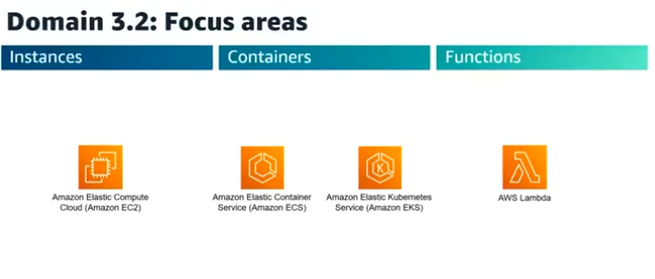
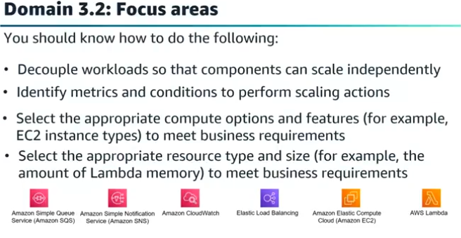

Walkthrough question 3.2 Apr 2, 2026
This lecture focuses on analyzing a scenario where an application processes photos and videos using Amazon EC2 On-Demand Instances, and users experience slow performance and dropped requests during peak hours.
Problem Identification and Key Points
- The processing job can take up to one hour, and the current architecture uses Auto Scaling groups behind an Application Load Balancer.
- During peak hours, the application is slow and sometimes fails to process requests; during off-peak hours, resources are idle.
- The question asks for the most cost-effective solution to ensure all jobs are processed.
Evaluation of Proposed Solutions
- Using larger instance sizes improves performance but increases costs and does not address idle resources at night.
- Switching to Spot Instances reduces cost but does not solve scaling or request dropping issues and has availability risks.
- Using AWS Lambda is unsuitable because the job duration exceeds Lambda's maximum execution time of 15 minutes.
Recommended Solution: Decoupling with SQS
- Introducing an Amazon SQS standard queue between the web and processing layers allows buffering of jobs.
- A custom queue metric can trigger Auto Scaling of processing instances based on queue depth, ensuring timely processing.
- This approach prevents dropped requests during peak times and is cost-effective by scaling resources only as needed.
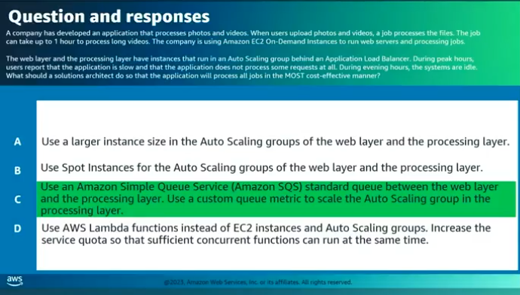

Determine high-performing database solutions Apr 2, 2026
This lecture focuses on determining high-performing database solutions in AWS applications, emphasizing performance optimization and appropriate database selection.
AWS Database Options and Management
- AWS offers multiple purpose-built database engines: relational, key-value, document, in-memory, graph, time series, and ledger databases.
- AWS manages database tasks like provisioning, patching, backups, and recovery, enabling focus on application development.
Choosing the Right Database Solution
- Optimal database choice depends on availability, consistency, partition tolerance, latency, durability, scalability, and query needs.
- Different database engines suit different use cases; for example, DynamoDB offers consistent single-digit millisecond performance and high volume handling, while Aurora provides advanced clustering and replication features.
Performance Optimization Techniques
- Use read replicas, multi-AZ deployments, and understand differences between RDS and Aurora architectures for improved availability and read performance.
- Employ caching solutions like ElastiCache or DynamoDB Accelerator (DAX) and connection management tools like RDS Proxy to enhance throughput and scalability.
Capacity Planning and Auto-Scaling
- Select appropriate instance types and sizes; enable storage auto-scaling where applicable.
- Aurora Serverless offers on-demand auto-scaling with Aurora Capacity Units (ACUs), scaling compute capacity based on load and pausing during inactivity for cost savings.
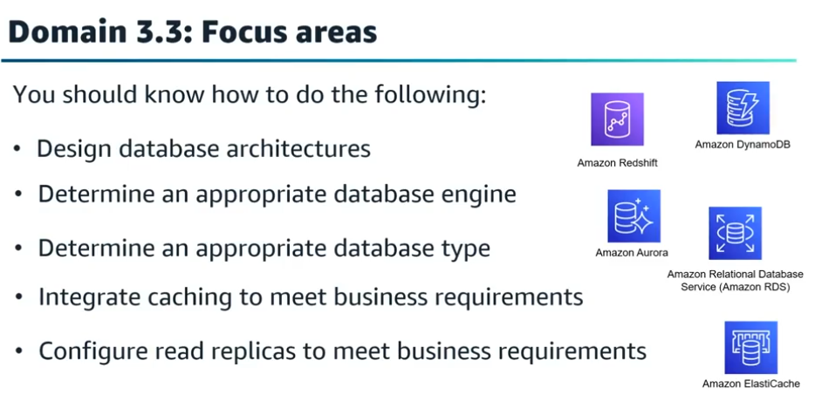
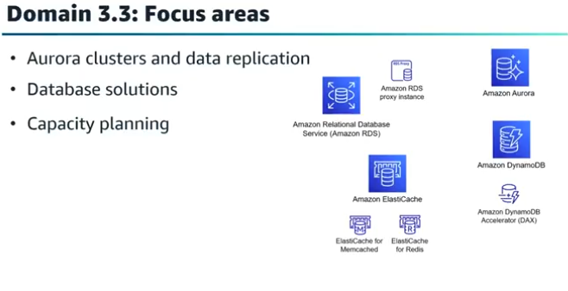
Walkthrough question 3.3 Apr 2, 2026
This course item focuses on a walkthrough question related to designing a scalable, high-performing architecture for processing spiky IoT sensor data using AWS services.
Key Concepts of the Question
- The application must handle spiky data from wind turbines, store it in a key-value database, and send it to a centralized data lake for analysis.
- The solution should scale automatically and have minimal operational overhead.
Correct Solution Components
- Use Amazon DynamoDB as the key-value database to store IoT sensor data because it scales automatically and handles spiky access patterns well.
- Enable Kinesis Data Streams on DynamoDB to capture item-level changes and stream data efficiently.
- Configure Amazon Kinesis to deliver streaming data from Kinesis Data Streams to an Amazon S3 data lake, which supports diverse data sources and requires less operational overhead.
Why Other Options Are Incorrect
- Amazon DocumentDB is not a key-value database, so it does not meet the storage requirement.
- Using AWS Lambda functions to move data to S3 adds operational overhead due to custom code.
- Delivering data to Amazon Redshift is less suitable than S3 for a data lake scenario requiring integration of diverse datasets.
Exam Strategy Highlight
- Identify keywords in the question, eliminate distractors, and carefully compare plausible answers to select the best combination that meets all requirements.
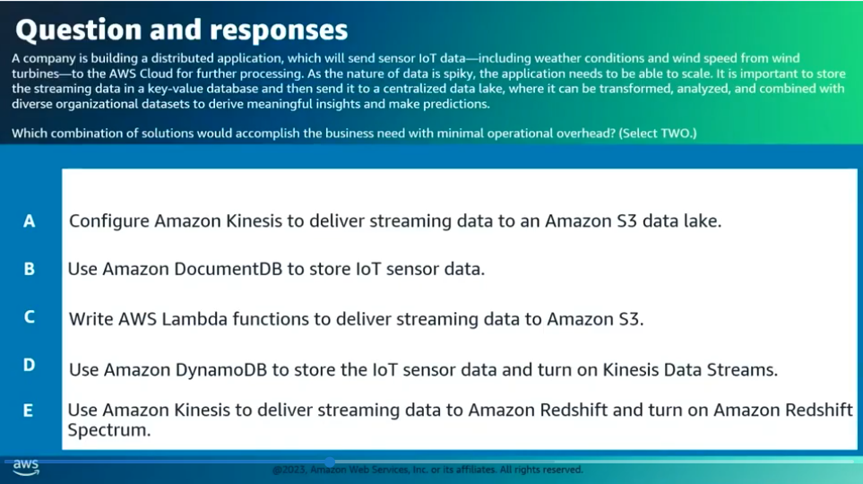

Determine high-performing and/or scalable network architecture Apr 2, 2026
This lecture focuses on determining high-performing and scalable network architectures for the AWS Certified Solutions Architect - Associate exam.
Networking Fundamentals and AWS Networking Services
- Understand networking basics as they impact architecture performance; AWS networking is virtualized with various types and configurations.
- AWS offers features like enhanced networking, EBS-optimized instances, S3 Transfer Acceleration, CloudFront, Route 53 latency routing, VPC endpoints, Direct Connect, and Global Accelerator to optimize and reduce network latency and jitter.
Designing and Securing Amazon VPC and Hybrid Architectures
- Know how to design, build, and secure Amazon VPCs, including components like subnets, route tables, internet gateways, security groups, NAT gateways, and endpoints.
- Design hybrid architectures connecting on-premises data centers to AWS using VPN, Direct Connect, Transit Gateway, and AWS CloudHub for private communication and data transfer.
Optimizing Network Performance and Scalability
- Use Route 53 routing policies, Global Accelerator, and CloudFront to optimize traffic routing, performance, and caching closer to end users.
- Understand data transfer services (DataSync, Snow Family, Transfer Family, Database Migration Service) to select appropriate solutions for data migration.
- Architect scalable solutions using auto scaling, load balancing, and serverless architectures to meet global customer demand with high availability and low latency.
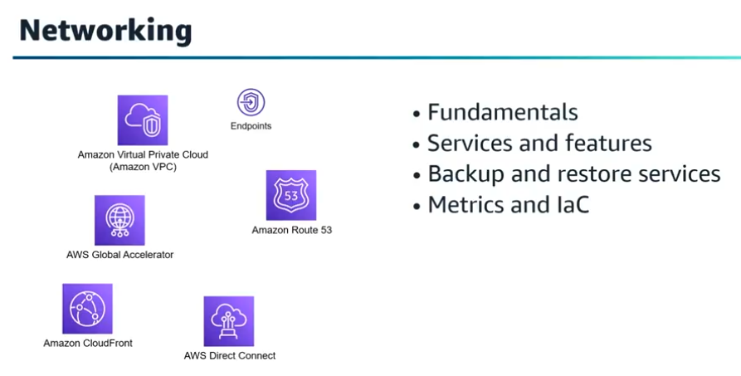

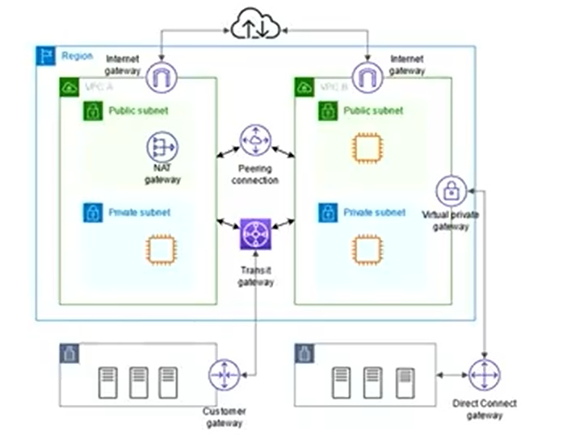

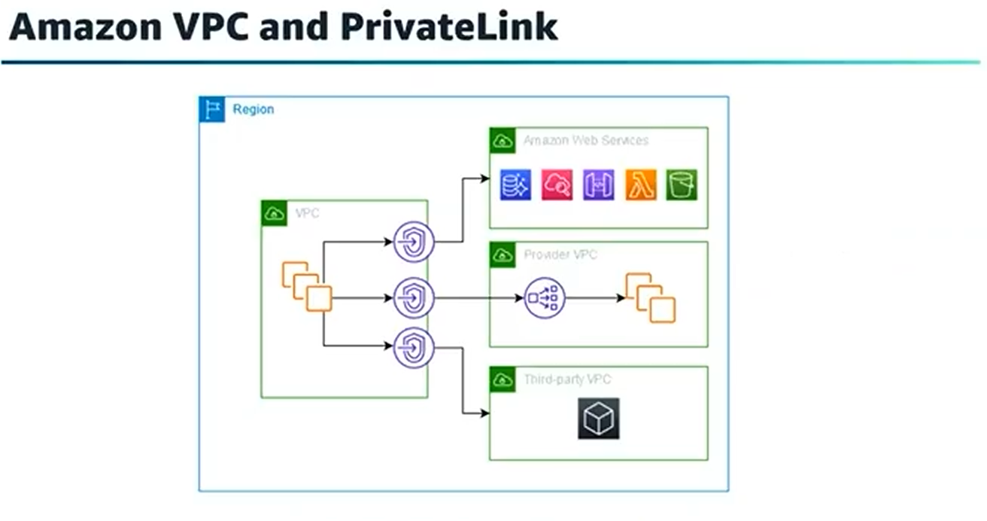

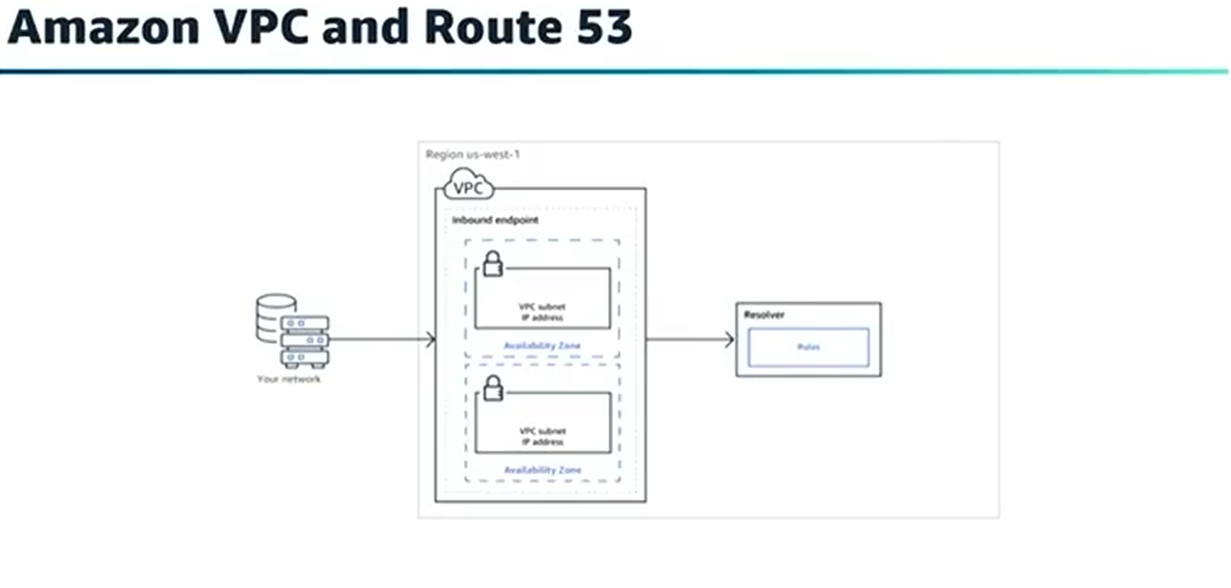

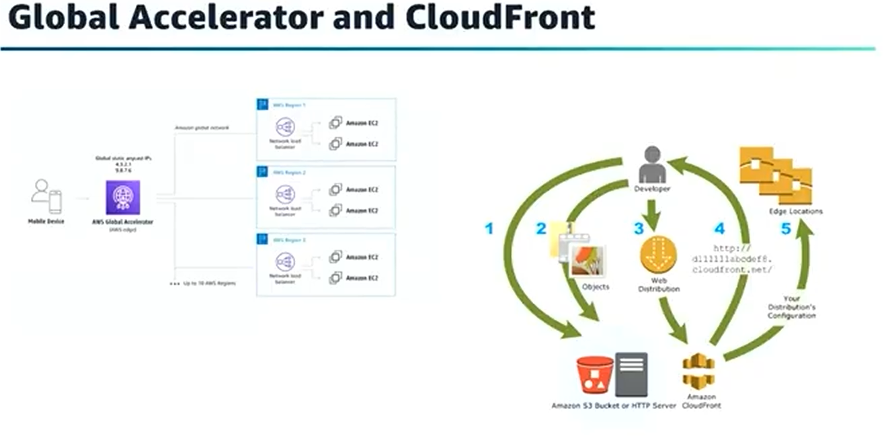
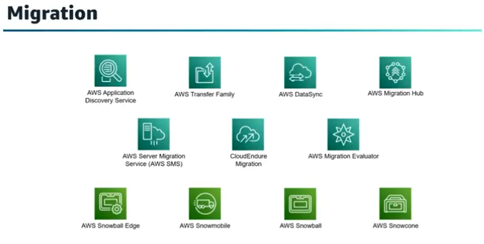

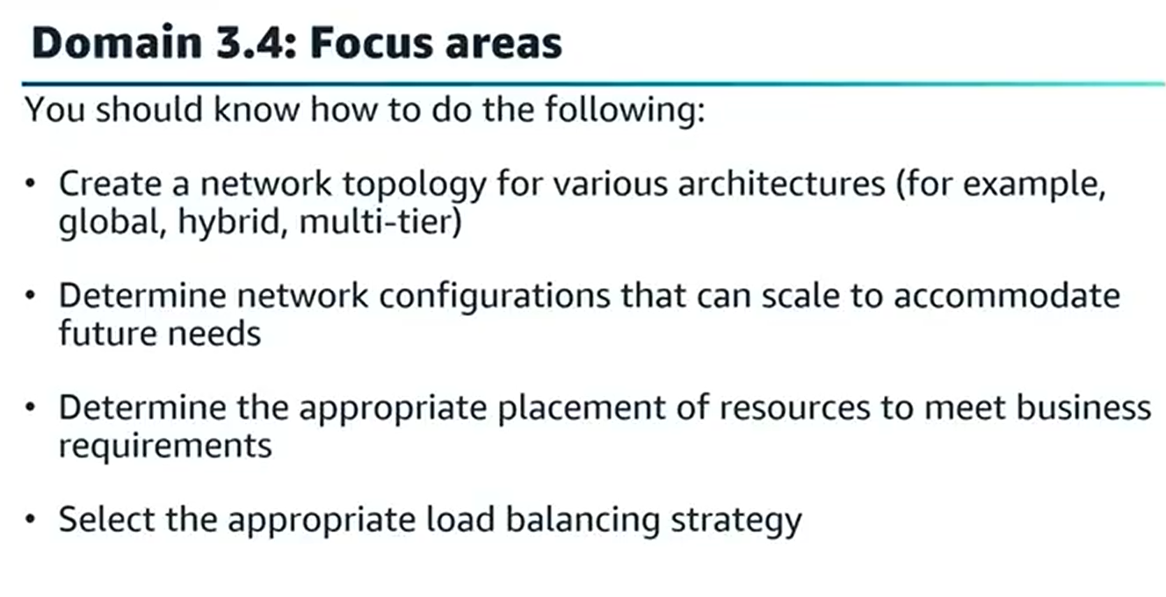

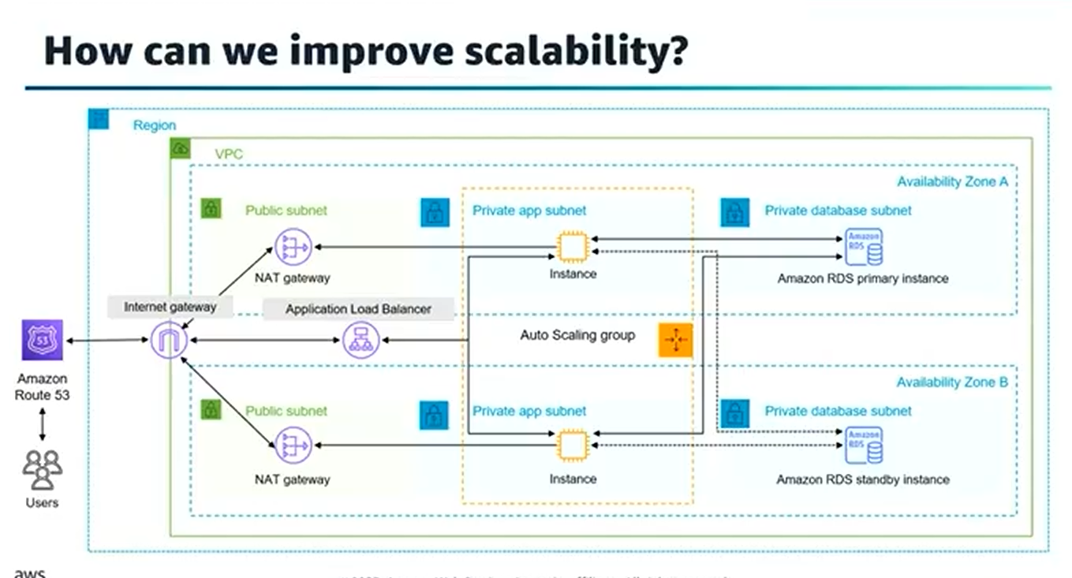

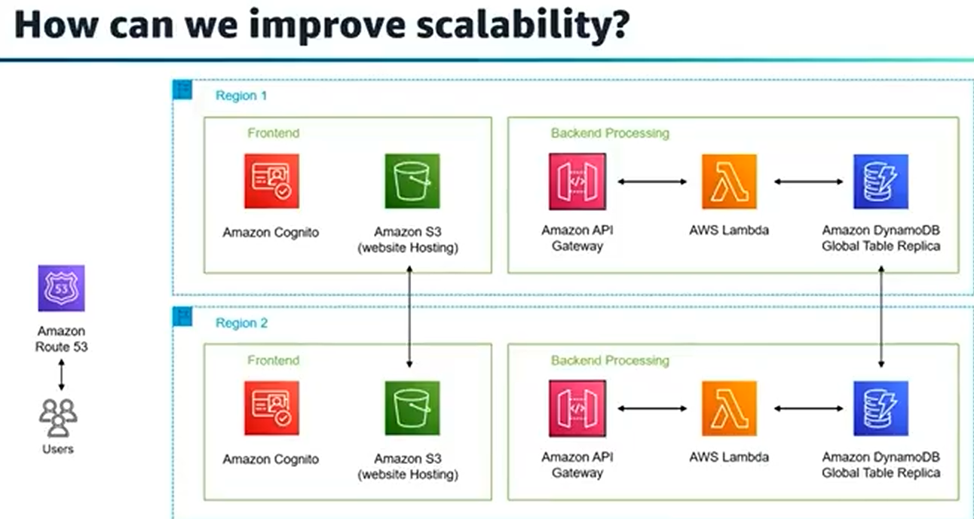

Walkthrough question 3.4 Apr 3, 2026
This course item explains how to connect multiple AWS accounts and VPCs to a shared services VPC with minimal operational overhead.
Key Concepts of Multi-Account VPC Connectivity
- The scenario involves over 50 AWS accounts, each with multiple VPCs, needing access to a shared services VPC.
- The goal is to enable communication among all VPCs with high trust and minimal management effort.
AWS PrivateLink as the Optimal Solution
- AWS PrivateLink is preferred over VPC peering for this use case because it supports directional access from multiple consumer VPCs to a service provider VPC.
- Setting up PrivateLink involves creating a network load balancer in the shared services VPC, IAM service consumer roles, auto-accepting endpoint connections, and consumer endpoints in each division VPC pointing to the load balancer.
Evaluation of Other Options
- Application Load Balancer with CAA records is incorrect because CAA records control certificate authorities, not routing.
- VPC peering is limited by a maximum of 125 peering connections per VPC, insufficient for the scale described.
- VPN connections would require more operational overhead to maintain compared to PrivateLink.
Exam Strategy Advice
- Carefully read questions and answers to identify keywords and eliminate distractors.
- Understand how to architect networking strategies for multi-account AWS setups, especially involving shared services VPCs.
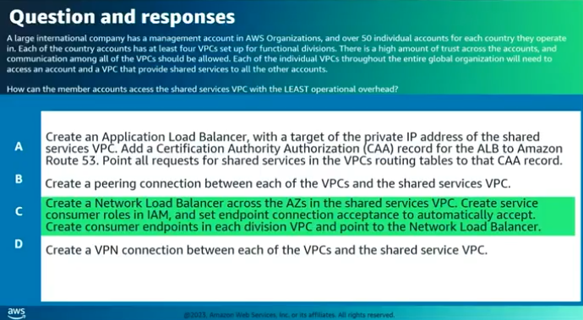

Determine high-performing data ingestion and transformation solutions Apr 3, 2026
This course item focuses on determining high-performing data ingestion and transformation solutions within AWS architectures.
Data Ingestion Patterns
- Homogeneous ingestion involves moving data in the same format or storage engine, emphasizing speed, data protection, and automation using services like Amazon Athena or Amazon EMR.
- Heterogeneous ingestion requires transforming data during ingestion to meet destination requirements, including format changes or deriving new attributes, often using streaming services.
Streaming Data and AWS Kinesis
- Amazon Kinesis offers real-time data streaming capabilities with services like Kinesis Data Streams for ingesting streaming data and Kinesis Video Streams for streaming video.
- Kinesis Data Firehose simplifies capturing, transforming, and loading data streams into AWS data stores, while Kinesis Data Analytics provides basic data transformation options.
Data Processing, Storage, and Optimization
- Data extracted needs transformation and loading into data stores for machine learning or analytics, using services like Amazon EMR, AWS Glue, and AWS Lake Formation.
- Optimization techniques include adjusting S3 request concurrency, retry strategies, and transforming data formats (e.g., to Parquet) to improve performance and cost-efficiency.
Data Lakes and Analytics
- Data lakes on Amazon S3 enable centralized storage of structured and unstructured data, supporting quick ingestion, reduced duplication, and centralized governance.
- Services like Amazon Athena, AWS Lake Formation, and Amazon QuickSight support data analytics and visualization with agility and flexibility.
Data Transfer and Integration Services
- AWS offers various services for data transfer from on-premises to cloud, including the Snow Family, AWS DataSync, Transfer Family, Direct Connect, and Database Migration Service.
- AWS Glue facilitates data discovery, preparation, movement, and integration for analytics, machine learning, and application development.
Security and Governance
- Managing security in hybrid environments involves access policies, encryption with S3 and KMS, tagging, and user policies to control data access.
- Encryption options and key management services like KMS, API Gateway, Cognito, and CloudHSM help protect data assets and meet compliance requirements.
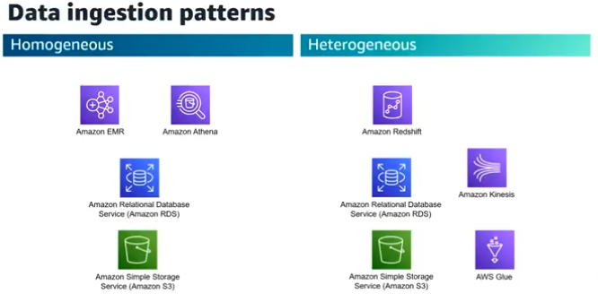
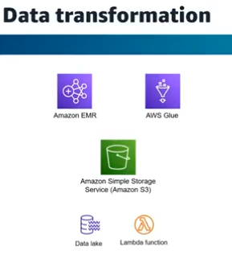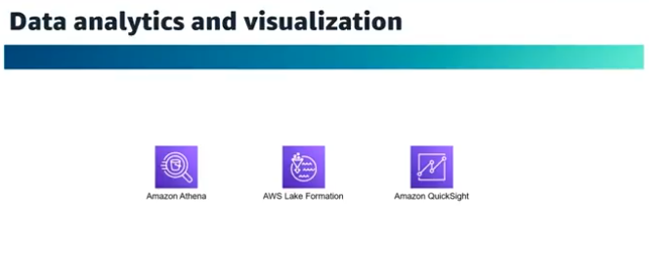

Domain 3 – wrap up Apr 3, 2026
This course item summarizes key topics for designing high-performing architectures as an AWS Solutions Architect, focusing on exam preparation.
High-Performing Storage and Compute Solutions
- Understand different storage types: object (S3), block (EBS), and file storage (EFS, FSx).
- Know how to scale compute services like EC2, Batch, EMR, Fargate, and Lambda.
Serverless and Messaging Services
- Be familiar with SQS and SNS, including error handling and quotas in Lambda processing.
- Understand serverless technologies such as API Gateway (throttling, quotas), Step Functions, EventBridge, and AppSync (GraphQL interface).
Database, Networking, and Data Ingestion
- Know capabilities and limitations of RDS, Aurora, DynamoDB, ElastiCache, Redshift, and caching strategies.
- Understand network optimization with CloudFront, Global Accelerator, VPC endpoints, and VPC setup basics.
- Learn data ingestion and transfer services like Data Sync, Storage Gateway, AWS Transfer Family, Snow Family, Kinesis, Athena, Lake Formation, QuickSight, Glue, and EMR for data processing.
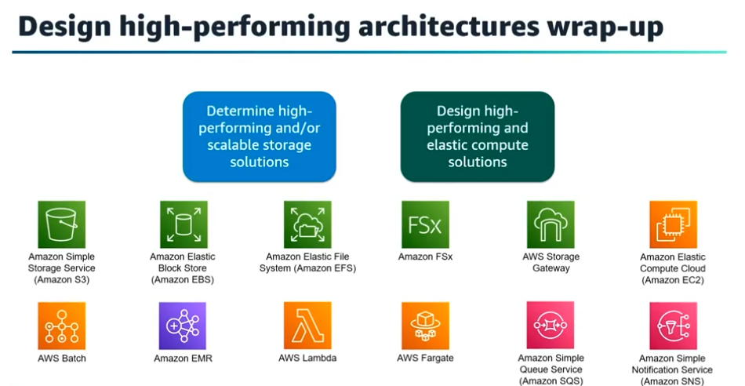
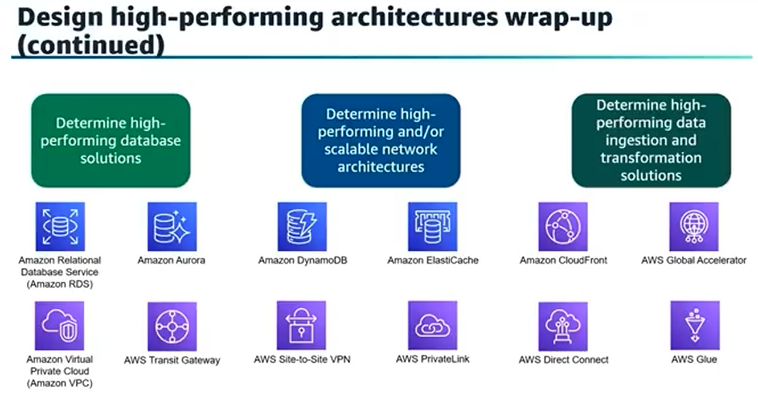

Domain 4 Introduction Apr 3, 2026
This course item introduces Domain 4 of the AWS Certified Solutions Architect - Associate exam preparation, focusing on designing cost-optimized architectures.
Cost-Optimization Overview
- Cost-optimization means delivering business value at the lowest possible price point.
- It is one of the pillars of the AWS Well-Architected Framework, emphasizing design principles and best practices.
Domain 4 Task Statements
- The domain is divided into four key tasks: designing cost-optimized storage, compute, database, and network solutions.
- Each task will be addressed individually in subsequent videos to build the necessary knowledge and skills.
Course Structure and Exam Readiness
- The course will break down each task statement to help learners prepare effectively for the exam.
- The next video will start with designing cost-optimized storage solutions and include an evaluation of exam readiness.
Design cost-optimized storage solutions Apr 3, 2026
This lecture focuses on designing cost-optimized storage solutions within AWS, emphasizing the importance of selecting appropriate storage types and monitoring usage to control costs.
Understanding Storage Solutions
- Different storage types exist, such as ephemeral storage, EBS (Elastic Block Store), and S3 (Simple Storage Service), each suited for specific use cases and cost considerations.
- Right-sizing storage, like avoiding over-provisioning EBS volumes, is key to cost optimization.
Cost Optimization and Monitoring Tools
- Ephemeral storage is included in EC2 instance costs but is not for persistent data; EBS offers persistent block storage with additional costs.
- AWS tools like Trusted Advisor, CloudWatch, Cost Explorer, and AWS Budgets help monitor usage, identify underutilized resources, and manage costs effectively.
S3 Storage Classes and Lifecycle Management
- S3 offers multiple storage classes balancing cost, durability, and retrieval times, with lifecycle policies to transition or delete data automatically.
- Intelligent Tiering automatically moves objects to cost-effective tiers based on access patterns, aiding in cost savings.
Data Transfer and Migration Cost Optimization
- Efficient data migration methods include AWS Snowball, Snowmobile, Direct Connect, and others, chosen based on data size and security needs.
- Architecting data transfer with tools like CloudFront and Direct Connect helps minimize transfer costs.
Cost Management Best Practices
- Implement tagging strategies for cost allocation and regularly review infrastructure usage.
- Use auto-scaling to match resource allocation with demand, avoiding unnecessary costs.
By mastering these concepts, you can design AWS storage architectures that meet technical requirements while optimizing for cost efficiency.
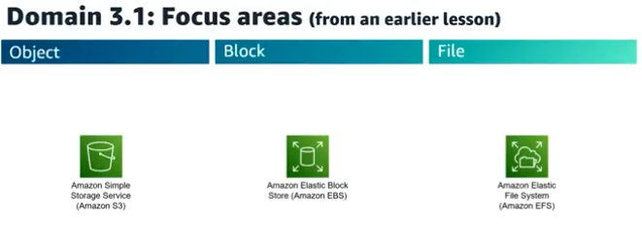
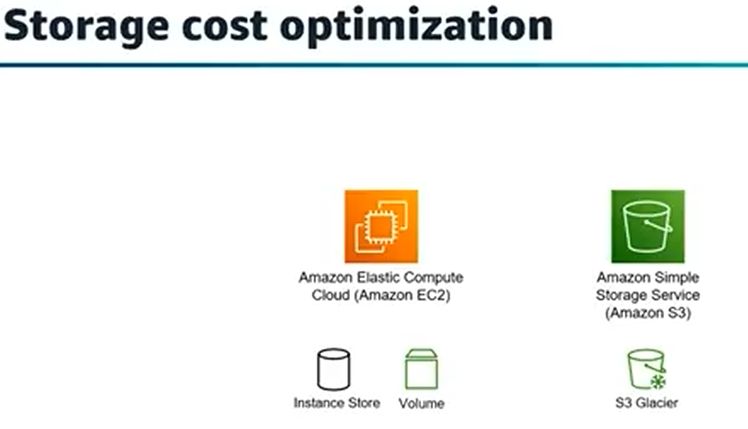
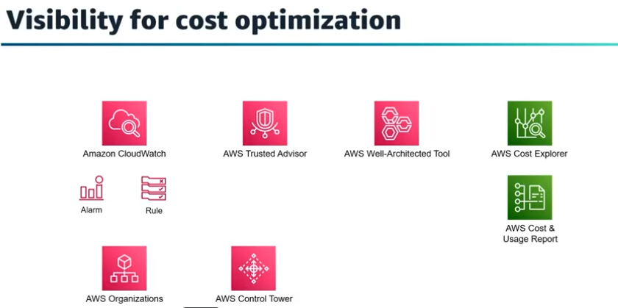
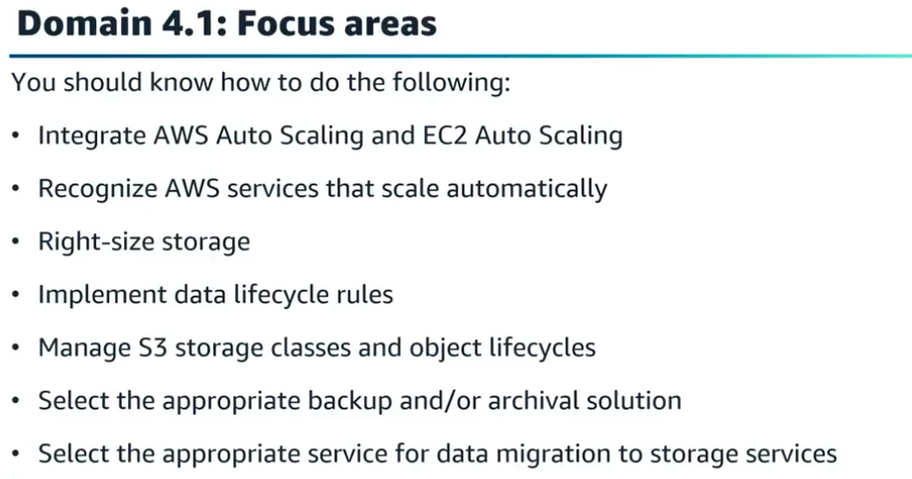

Walkthrough question 4.1 Apr 3, 2026
This course item focuses on evaluating the best AWS storage solution for migrating Microsoft Windows servers requiring shared file access integrated with Active Directory.
Key considerations for the storage solution
- Must support Microsoft Windows servers and shared file systems.
- Needs integration with existing Active Directory for file and folder permissions.
- Should enable seamless shared file access between AWS and on-premises servers.
- Requires high availability and encryption both at rest and in transit.
Evaluation of possible AWS storage options
- Amazon FSx for Windows File Server: Fully managed native Windows file system, integrates with Active Directory, supports high availability and encryption.
- Amazon S3 File Gateway: Provides file interface to S3 but does not maintain Active Directory permissions once data is in S3.
- Amazon Elastic File System (EFS): Designed for Linux workloads, not suitable for Windows servers.
- Amazon S3 bucket mounted on EC2: S3 is object storage, not a native file system, and cannot be mounted directly for shared file access.
Conclusion and best choice
- Amazon FSx for Windows File Server is the best fit as it meets all requirements including Windows compatibility, Active Directory integration, high availability, and encryption.
- The course emphasizes carefully reading exam questions, identifying keywords, eliminating incorrect options, and selecting the best answer based on AWS service capabilities.
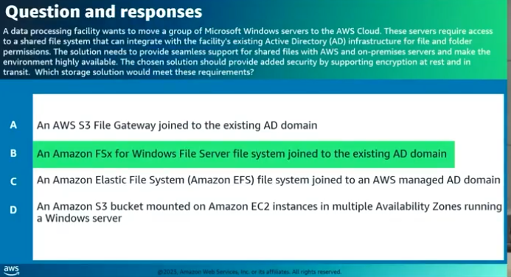

Design cost-optimized compute solutions Apr 3, 2026
This lecture focuses on designing cost-optimized compute solutions within AWS, emphasizing the importance of selecting appropriate resources and pricing models to reduce costs effectively.
Key Concepts in Compute Cost Optimization
- Use managed services instead of maintaining servers to reduce costs.
- Choose the right instance family (compute-optimized, memory-optimized) based on workload requirements.
Cost Optimization Pillars
- Right-sizing: Select the cheapest instance type that meets performance needs, including hybrid compute options like Outpost and Snowball Edge.
- Increase elasticity: Use auto scaling and smaller instances to pay only for resources when needed.
- Pricing models: Understand options such as On-Demand, Savings Plans, Reserved Instances, and Spot Instances to match workload tolerance for interruptions.
- Storage matching: Right-size storage to compute needs to avoid unnecessary costs.
- Continual improvement: Monitor usage and costs with tools like CloudWatch and Cost Explorer, and enforce tagging strategies for cost allocation.
Load Balancing and Auto Scaling
- Combine right-sized instances with elastic load balancers to scale horizontally.
- Use Application, Network, or Gateway Load Balancers based on use case and cost considerations.
- Configure auto scaling groups with load balancer metrics and health checks to maintain optimal resource usage and cost efficiency.
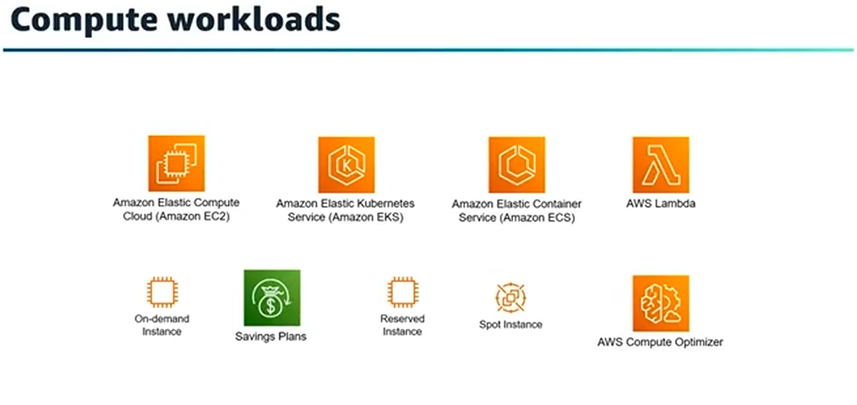
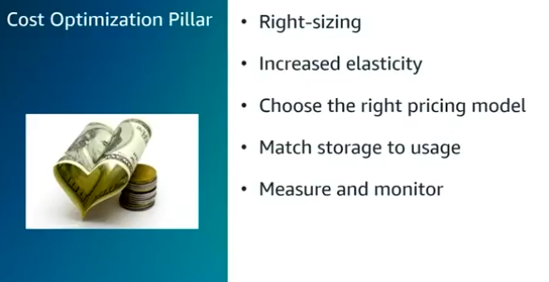

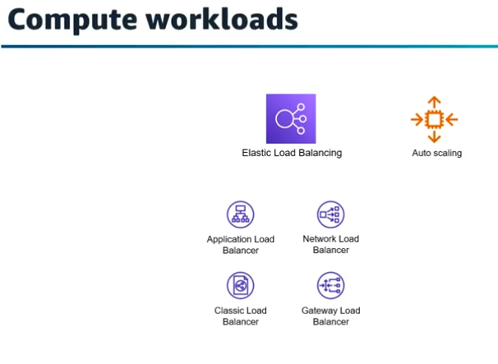
Walkthrough question 4.2 Apr 3, 2026
This course item explains how to select a cost-effective, scalable, and secure solution for running microservices without managing infrastructure.
Key Requirements for the Solution
- Must run microservices without operational overhead of managing infrastructure.
- Needs to scale quickly to handle rapid changes in request volume.
- Should protect against common DDoS attacks.
- Must be cost-effective, paying only for actual usage.
Correct Solution: AWS Lambda with API Gateway
- AWS Lambda is serverless, eliminating infrastructure management and idle resource costs.
- API Gateway and Lambda scale automatically and rapidly to meet demand.
- API Gateway provides built-in DDoS protection and request throttling to safeguard backend services.
- This combination ensures cost efficiency by charging only for requests handled.
Why Other Options Are Less Suitable
- Elastic Beanstalk and EC2 Auto Scaling involve managing EC2 instances, which take time to scale and incur costs even when idle.
- ECS with EC2 also requires cluster scaling that is slower and less cost-effective due to EC2 resource usage.
- These options do not meet the rapid scaling and cost-effectiveness requirements as well as Lambda with API Gateway.
The lesson emphasizes reading exam questions carefully to identify keywords, eliminate distractors, and choose the best answer based on service features like scaling, security, and pricing.
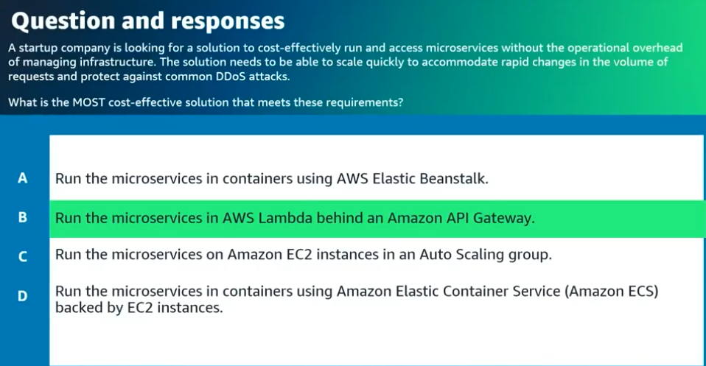

Design cost-optimized database solutions Apr 3, 2026
This lecture focuses on designing cost-optimized database solutions within AWS as part of the AWS Certified Solutions Architect - Associate exam preparation.
Choosing the Right Data Store
- Understand different AWS storage services and types of data stores, including relational databases, NoSQL, and object storage.
- Select data stores based on access patterns, scale, growth, and frequency of data access to optimize performance and cost.
Cost Optimization Strategies
- Migrate subsets of relational data to EC2, RDS, S3, or NoSQL stores like DynamoDB to reduce costs and improve availability.
- Use managed services like DynamoDB to offload administrative tasks such as scaling, patching, and replication.
Scaling and Backup Considerations
- Choose appropriate scaling strategies: horizontal scaling with read replicas or caching is often more cost-effective than vertical scaling.
- Design backup plans to meet Recovery Point Objectives (RPO) and use point-in-time recovery features while managing snapshot retention to avoid unnecessary storage costs.
Overall, the lecture emphasizes understanding your data and workload characteristics to select the right AWS database services and scaling methods for cost efficiency and performance.
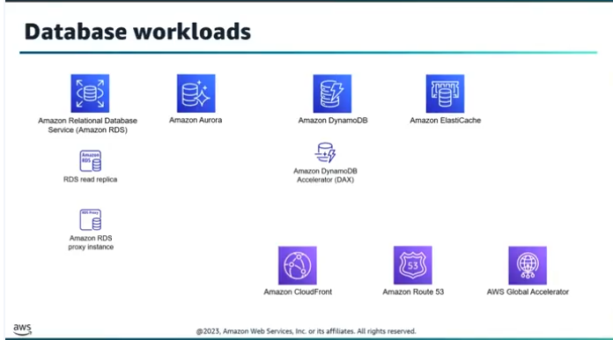

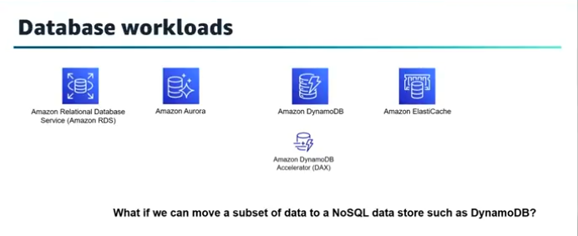

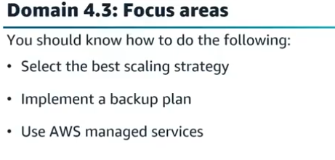

Design cost-optimized network architectures Apr 3, 2026
This lecture focuses on designing cost-optimized network architectures in AWS, emphasizing efficient use of networking resources to minimize costs.
AWS Networking and Cost Considerations
- AWS networking is virtualized and managed, eliminating the need to operate physical network equipment; costs are based on usage similar to CPU and storage.
- API calls and data transfer costs are important factors often overlooked in cost optimization.
Network Connectivity Options and Cost Implications
- For private connections between on-premises and AWS, VPN connections are generally more cost-effective than Direct Connect unless higher throughput or security is required.
- Different methods to connect to AWS resources (SSH, Systems Manager Session Manager, EC2 Instance Connect) have varying cost implications.
- VPC peering can be more cost-effective than transit gateways for inter-VPC or cross-region data transfer, which incurs charges.
Strategies to Minimize Data Transfer and Service Costs
- Use VPC gateway endpoints for S3 and DynamoDB to avoid data transfer charges within the same region.
- Minimize cross Availability Zone traffic to reduce data transfer costs.
- Optimize NAT Gateway deployment by sharing gateways in development environments and using one per Availability Zone in production.
- Use CloudFront to cache content and reduce data transfer out of S3, lowering costs.
- Monitor network usage and costs with AWS tools like CloudWatch, Config, and Transit Gateway Network Manager to identify optimization opportunities.
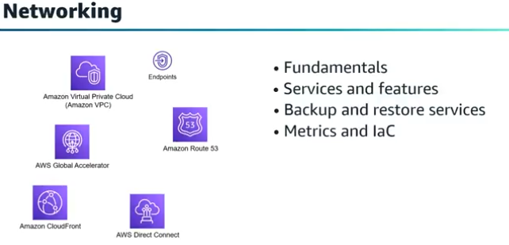

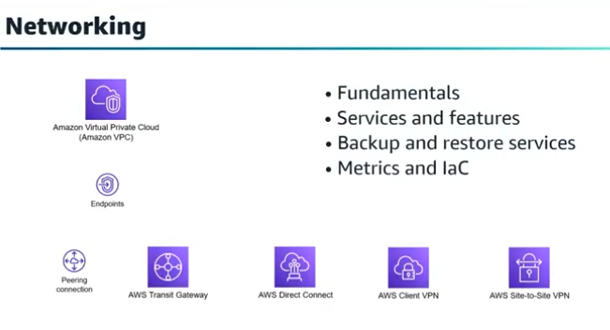

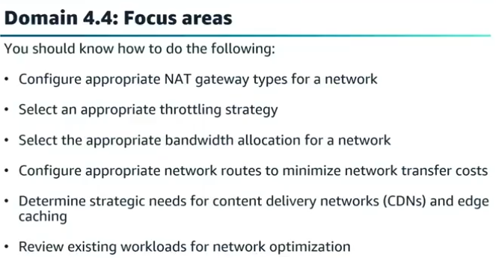

Walkthrough question 4.4 Apr 3, 2026
This course item focuses on a walkthrough question related to securely and cost-effectively enabling developer login to Amazon EC2 instances in a private subnet.
Key Concepts of the Question
- The scenario involves EC2 instances in a private subnet using a NAT gateway for internet access.
- The main requirements are secure login access for developers and cost-effectiveness.
Answer Options and Explanation
- Correct answer: Use AWS Systems Manager Session Manager to enable login without opening inbound ports or managing SSH keys, with no additional cost.
- Bastion host option incurs extra EC2 instance charges, making it less cost-effective.
- NAT gateway cannot be used for inbound login because it only supports outbound traffic.
- Site-to-Site VPN works but adds extra cost, so it is not the most cost-effective.
Exam Strategy and Recommendations
- Identify keywords in the question to understand requirements.
- Eliminate distractors by understanding AWS service functionalities and cost implications.
- Review cost and connectivity features of AWS services to choose the best answer.
- Practice hands-on labs and review domain concepts to prepare for the exam.
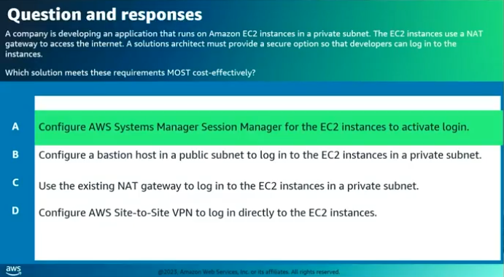

Domain 4 wrap-up Apr 3, 2026
This course item focuses on designing cost-optimized architectures in AWS, emphasizing how to manage and reduce cloud costs effectively.
Cost Optimization Strategies
- Cloud's variable cost model allows iterative cost management by paying only for what is used monthly.
- Monitoring resource usage, such as underutilized EC2 instances, enables right-sizing or scaling to reduce costs.
Compute and Storage Cost Management
- Selecting appropriate instance types, sizes, and pricing models (on-demand, reserved, spot) impacts compute costs.
- For storage, using correct S3 storage classes and automated tiering (e.g., Intelligent-Tiering, Lifecycle Configurations) optimizes expenses based on access patterns.
Cost Management Tools and Best Practices
- Utilize AWS cost management tools like Cost Explorer, Cost and Usage Report, and Budgets for tracking and controlling expenses.
- Tagging resources properly helps in detailed cost reporting and analysis.
Database and Networking Cost Considerations
- Choose the right database service and optimize with caching, query tuning, and design adjustments to reduce costs.
- Understand networking services, configurations, and pricing to minimize data transfer and infrastructure expenses.
Architectural Decision-Making for Cost Efficiency
- Start with solutions that meet requirements, then evaluate multiple designs for cost optimization opportunities.
- Consider specific strategies like minimizing NAT gateway usage, optimizing network routes, and selecting cost-effective services for workloads.
